Ansible SSH Connection

Follow the below steps to establish ssh connection between master and slave,

In the **slave**machine, execute the below command,

* **sudo nano /etc/ssh/sshd_config**

Search and change the below lines as below,

* **PermitRootLogin yes**
* **PasswordAuthentication yes**

For the first parameter (**PermitRootLogin**), by default this line will be commented, you need to uncomment it and also change the value to **yes.**For the second parameter, the default value will be **no**and you need to change it to **yes.**

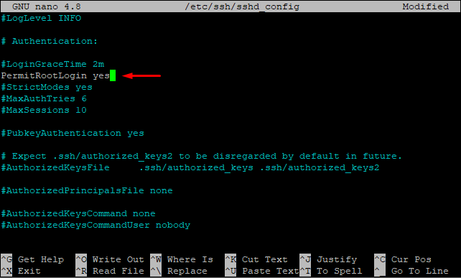

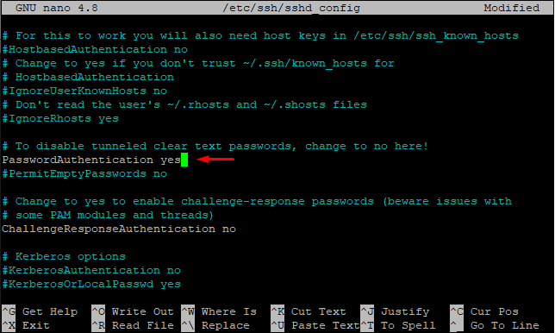

Save and exit with **ctrl+x**-> **y**-> **enter**

Execute the below commands now,

* **sudo systemctl restart sshd**
* **sudo su**
* **passwd**

Provide the password now.

Now in the **master**machine, execute the below commands,

* **sudo su**
* **ssh-keygen**

Press enter whenever asked without making any changes. A new public key will be generated. You need to copy this key to the slave machine. Execute the below command for the same,

* **ssh-copy-id -i ~/.ssh/id_rsa.pub root@public_ip_of_slave**

In the above command, change the **public_ip_of_slave** accordingly.

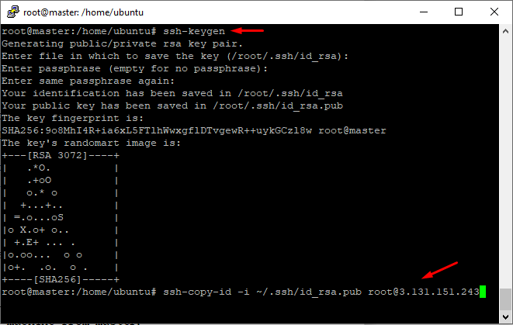

You will be asked to enter a password. Enter the password you set in the slave machine.

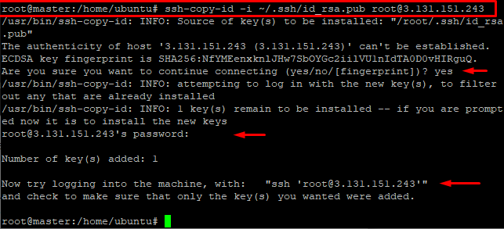

Now the ssh connection is established and now you can execute the below command to connect to the slave machine from master,

* **ssh root@public_ip_of_slave**

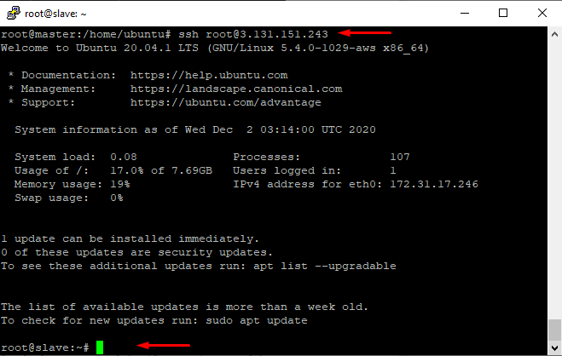

Execute the **exit** command to switch back to master instance.

Done.

**Ansible Inventory**

For ansible inventory, execute the below command in the master machine,

* **sudo nano /etc/ansible/hosts**

Add the below lines at the end of the file,

**[webserver]**

**root@private_ip_of_slave**

OR

**[webserver]**

**private_ip_of_slave**

Note: Instead of **private_ip_of_slave**, you can provide **public IP** as well.

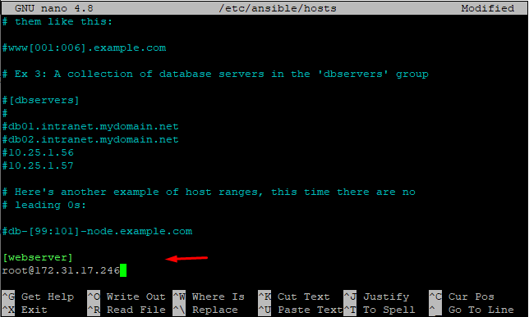

Here I have named the group **[webserver]** but you can provide any name for the group.

Save and exit with **ctrl+x**-> **y**-> **enter**

Change **private_ip_of_slave** accordingly. Execute the below command to check the connection,

* **ansible -m ping webserver**

If everything is fine, the output will be shown in green color and now you can execute the playbooks in the master machine.

